Special Tasks

# Assignment 1

## a)

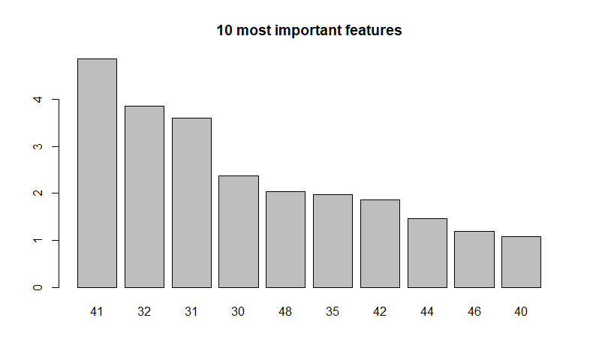

## b)

Confusion matrix:

|  |  |  |  |  |  |  |
| --- | --- | --- | --- | --- | --- | --- |
| **Confusion matrix** | | | **Prediction** | | | |
| **0** | | **1** | |
| **Actual** | **0** | 1604 | | 278 | |
| **1** | 144 | | 714 | |

# Assignment 2

Fitted tree with lm() in each node and with 5000 as min node size. Regression coefficients for each node is stated below:

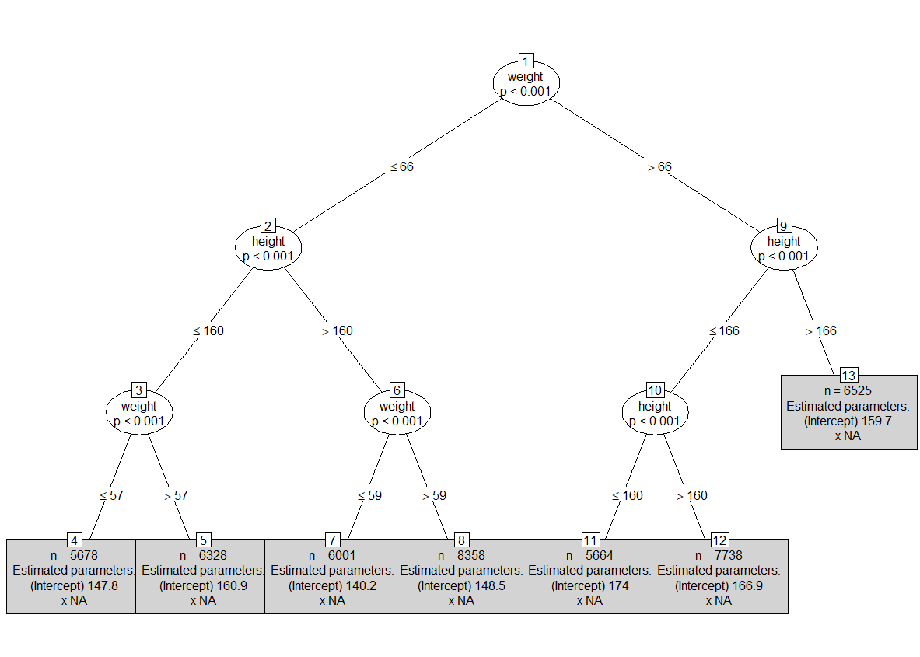

Color plot for grid with height as 111-210 and weight as 31-130. Grey to Red color scale where red corresponds to high values for Blood systolic.

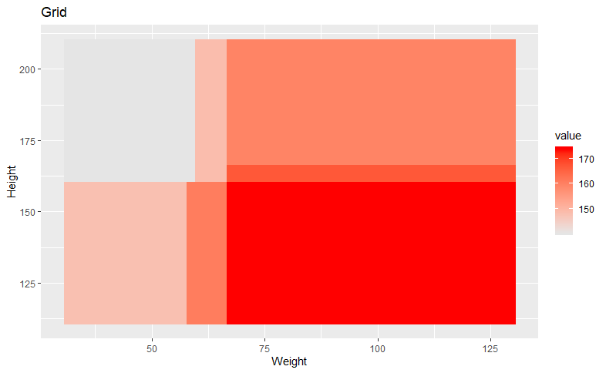

# Assignment 3

Error during each iteration:

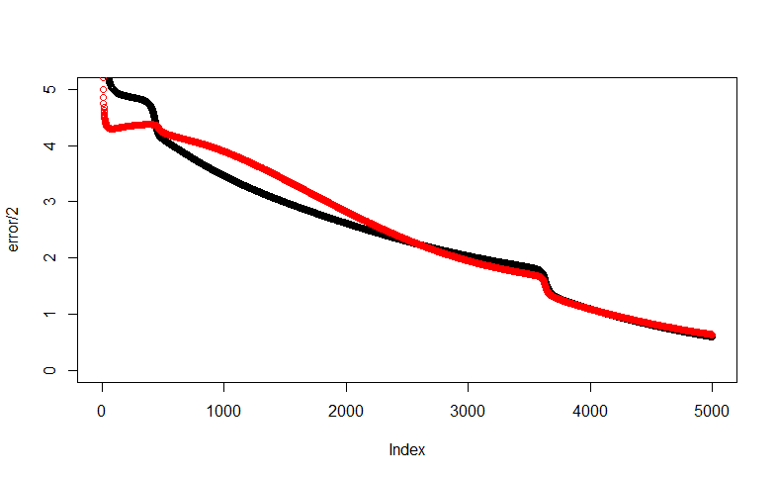

Predictions vs Actual for Training data:

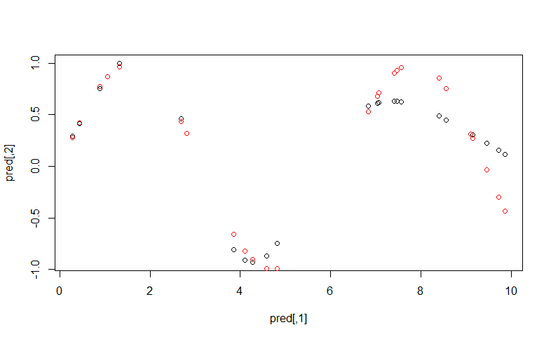

Predictions vs Actual for Validation data:

